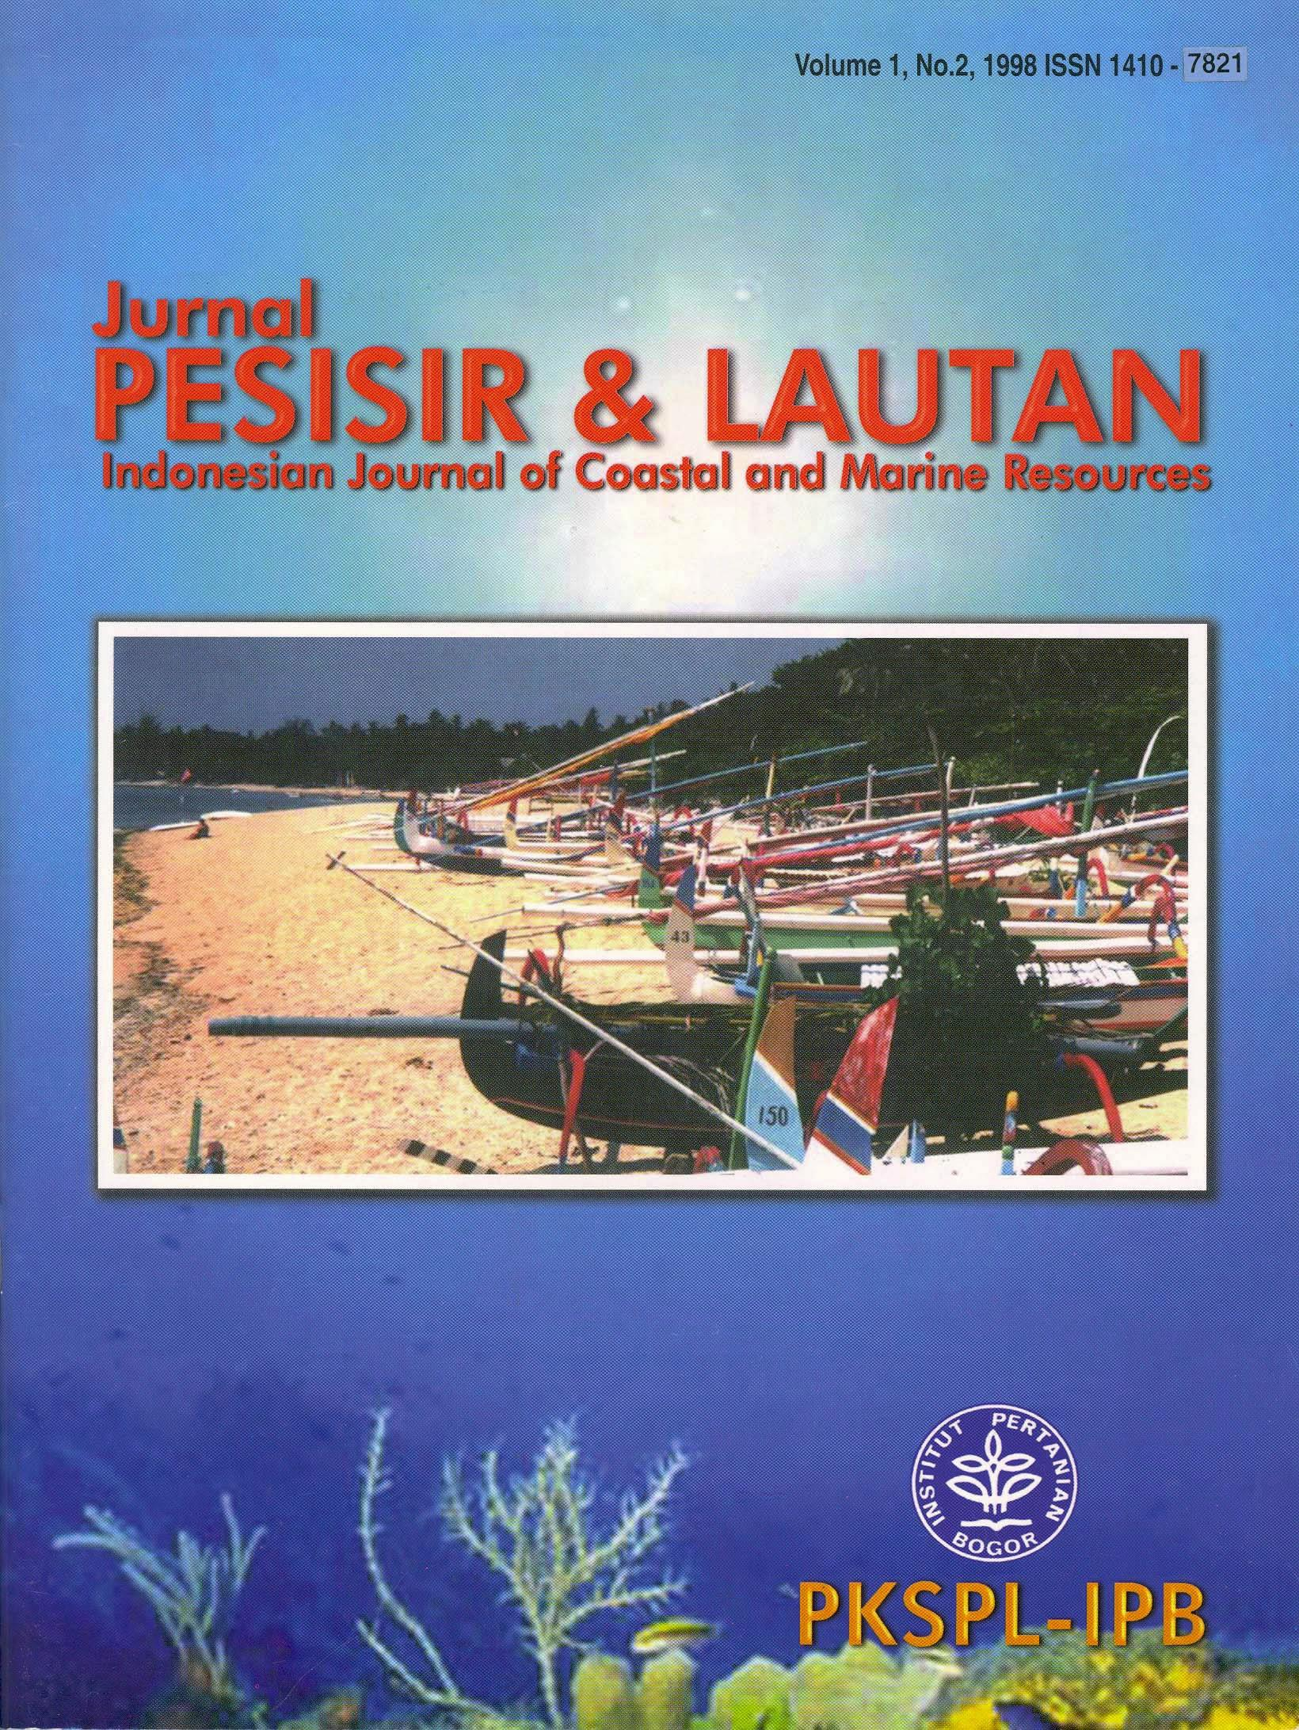

ISSN 1410-7821, Volume 1, No. 2, 1998

Pemimpin Redaksi
(Editor- in-chief)
Dietriech G. Bengen
Dewan Redaksi
(Editorial Board)
Rokhmin Dahuri
Ian Dutton
Richardus F. Kaswadji
Jacub Rais
Chou Loke Ming
Darmawan
Neviaty P. Zamani
Konsultan Redaksi
(Consulting Editors)
Herman Haeruman Js.
Anugerah Nontji
Aprilani Soegiarto
Agus Pakpahan
Irwandi Idris
Sapta Putra Ginting
Tridoyo Kusumastanto
Chairul Muluk
Effendy A. Sumardja
Iwan Gunawan
Daniel Mohammad Rosyd
Gayatrie R. Liley
Janny D. Kusen
J. Wenno, N.N.
Alamat Redaksi
(Editorial Address)
Pusat Kajian Sumberdaya Pesisir dan Lautan
(Center for Coastal and Marine Resources Studies)
Gedung Marine Center Lt. 4, Fakultas Perikanan dan Ilmu Kelautan IPB
Kampus IPB Darmaga Bogor 16680 INDONESIA
Tel/Fax. 62-251-621086, Tel. 62-251-626380
e-mail: awan-uri@indo.net.id
Halaman muka: Pantai Sanur, Bali (foto: Bengen, D.G., 1998)

Kata Pengantar

Edisi kedua “Jurnal Pengelolaan Sumberdaya
Pesisir dan Lautan Indonesia” kembali hadir
dengan perubahan judul, yakni “Pesisir &
Lautan”, menyusul edisi pertama yang terbit bulan
Maret 1998 dengan desain yang lebih menarik.

Judul baru tersebut diharapkan akan lebih
atraktif dan mudah diingat pembaca. Perubahan
judul jurnal ini tidak mengubah tema dan tujuan
jurnal, dimana masih membicarakan masalah-
masalah yang berkaitan dengan pengelolaan
sumberdaya pesisir dan lautan di Indonesia.
Penerbitan edisi kedua ini diharapkan akan
lebih bermanfaat dan dapat membantu semua
kalangan, terutama para pemerhati serta pihak-
pihak yang peduli terhadap pelestarian serta
pengelolaan sumberdaya pesisir dan lautan ,
sekaligus dapat berperan sebagai media informasi
dalam mengulas permasalahan pengelolaan
sumberdaya pesisir dan lautan.
Akhirnya saya ucapkan selamat membaca dan
kontribusi serta saran-saran anda kami tunggu
selalu.

Pemimpin Redak

Dr. Ir. Dietriech G. Bengen

Foreword

The second issue of “Jurnal Pengelolaan
Sumberdaya Pesisir dan Lautan” was presented
to you in different title: “Pesisir & Lautan” with
better style, following the first issue in March
1998.
The new title was intended to make it more
attractive and easily remembered by the readers.
However the changing of the title doesn’t effect
the theme and objectives of the journal, which
still within the issues related with coastal and
marine resources management in Indonesia.
The second issue was aimed to make it more
useful and helpful to all readers, observer and
persons concerned with conservation and
management of coastal and marine resources. It
also doubles as information media in discussing
management issue on coastal and marine
resources.
Enjoy the reading of this issue and your
comment, ideas and suggestions are most
welcome.

Editor in Chief

Dr. Ir. Dietriech G. Bengen

Pesisir & Lautan

IDENTIFICATION OF

Volume 1 No. 2, 1998

INDIGENOUS COASTAL FISHERIES MANAGEMENT
(ICFM) SYSTEM IN SULAWESI, MALUKU AND IRIAN
JAYA

VICTOR P.H. NIKIJULUW
Center for Agro Socio-Economic Research
Agency for Agricultural Research and Development, Bogor, Indonesia

ABSTRACT
This paper identifies and lists studies written on indigenous coastal fisheries management (ICFM). The objectives of
this desk research were to describe the similarities and varieties of the existing ICFM and to synthesize their possible
development as an alternative management system. A number of ICFM practices were found in Maluku, South and
North Sulawesi, and Irian Jaya. Most of the practices are tied with customary law and organized by local communities and
institutions. In a few cases, formal village government intervened to provide legal support to the systems. Factors that
affect the establishment and existence of the systems were: belief and structure of society, types of rules and regulations,
fishing intensity and technology, village government structure, and commodity price. Overall, the systems brought about
positive impacts to their adherents. This specific resource management system is effective and efficient provided traditional
rules and rights remain. The system also avoids resource utilization conflicts and provides more income to fishers. The
system may serve as a basis to co-manage coastal fisheries.
Keywords: Coastal fisheries management, indigenous fisheries management, people participation.

ABSTRAK
Upaya mengidentifikasi dan mendokumentasikan sistem pengelolaan perikanan pantai yang dianut secara
tradisional oleh penduduk lokal dilakukan di Maluku, Irian Jaya dan Sulawesi. Tujuannya adalah untuk mencari kesamaan
dan perbedaan yang diatasnya dapat disintesakan suatu sistem pengelolaan pantai alternatif. Peneltian ini adalah kajian
pustaka terhadap berbagai publikasi khususnya yang memiliki sirkulasi yang terbatas. Hasil kajian menunjukkan bahwa
sistem tradisional ini dipraktekan di ketiga daerah penelitian. Peranan lembaga adat, pemimpin informal, masyarakat
dan lembaga lokal sangat dominan dalam pelaksanaan aturan-aturan pengelolaan perikanan pantai. Di beberapa tempat,
pemerintah ikut terlibat terutama dalam memberikan dukungan hukum bagi pelaksaaan peraturan-peraturan lokal. Faktor-
faktor yang menopang dan mempengaruhi keberadaan sistem tradisional ini adalah kepercayaan dan struktur masyarakat,
bentuk peraturan, intensitas dan tekonologi penangkapan ikan, struktur pemerintahan desa, dan harga komoditas. Secara
umum dapat dikatakan bahwa sistem tradisional ini memiliki dampak positif kepada masyarakat. Sistem tradisional ini
dapat dikatakan efisien dan efektif karena sampai saat ini masih berlaku serta hampir tidak dijumpai pelanggarannya.
Selain itu, sistem ini dapat menghindari perselisihan dalam pemanfaatan sumberdaya serta memberikan pendapatan
yang lebih baik bagi nelayan. Sistem tradisonal ini dapat dijadikan dasar bagi pengembangan ko-manajemen perikanan
pesisir yang melibatkan masyarakat dan pemerintah.
Keywords: Pengelolaan perikanan pantai, pengelolaan perikanan masyarakat pantai, partisipasi masyarakat.

40

Identification of Indegenous...... (hal 40-56)

INTRODUCTION
Indigenous management describes folk
management systems based on local knowledge. The
systems have existed in parts of Indonesia for
centuries. Nevertheless, these important traditions
have not been well documented and studied. Their
documentation can be used, however, to improve
the management of coastal resources.
Use of indigenous knowledge to improve
coastal fisheries management is recognized in
many developing countries. (Pomeroy, 1994). An
approach to promote indigenous coastal fisheries
management system is to integrate the system into
regional or national management mechanisms.
Integration may take place if the regional or
national government legitimize the local traditional
system. (Pomeroy and Williams, 1994) and is often
referred to as cooperative management or co-
management. (McGoodwin, 1992). Although
Pomeroy and Williams (1994) argued that co-
management is not a panacea for fisheries
management, they listed its several advantages
against centralized or a top-down approach.
The indigenous management approach relies on
people participation. The need for participation in
natural resource management is clearly stated in
the Outline of the State Policy (GBHN). In the
closing GBHN chapter it is mentioned that national
development greatly depends on the active
participation, attitude, commitment, spirit and
enthusiasm of the society. Paragraph one of the
Environmental Act No. 23/1997 also states that
environmental management is an integrated effort
that involves everyone. Paragraphs five and seven
of the Act stipulate that everyone has the right to
manage natural resources and the environment.
The rights include decision making and the
implementation of management systems. It also
mentions (paragraph 10) that the government is
responsible to embody, develop and promote
management partnerships between government
and society. Therefore, the GBHN and
Environmental Act becomes solid ground for local
participation in coastal resource management.

41

This study documents and synthesizes work
undertaken on indigenous coastal fisheries
management (ICFM) systems in Sulawesi, Maluku
and Irian Jaya. The area has many island communities
that rely on coastal fishery resources. The area has
226,000 fishing establishments, slightly more than
the number of fishing companies in the rest of
Indonesia. About 44 percent of Indonesian fishers
live in the area. Although it has 54 percent of the
Indonesian fishing fleet, the boats are smaller and less
developed than boats in western Indonesia. Some
68 percent of the non-motorized boats are found in
the area. Fisheries in Sulawesi, Maluku and Irian Jaya
are therefore small-scale and concentrate on coastal
waters.
This study documents previous ICFM studies,
describes the systems and evaluates their impact
on society, and synthesizes the main ideas of
previous studies to form policy and
recommendations.
METHODOLOGY
This desk research is based on papers on ICFM
systems in Sulawesi, Maluku and Irian Jaya
gathered from institutions in Jakarta, Bogor, Ujung
Pandang and Ambon. This study was part of the
Fisheries Co-management Project to document
traditional fisheries management systems in Asia
and Africa. The papers collected were summarized
in English abstracts following a standardized
format. The abstracts include the following
information: title and author of article, source,
publisher, year published, language, subject,
objective, coverage, method of data collection and
analysis, and summary of findings. The abstracts
and collection of papers are archived with the
Fisheries Co-management Project of the
International Center for Living Aquatic Resource
Management (ICLARM), Manila Philippines, and
the North Sea Center, IFM, Hirtshals, Denmark.
Descriptive and comparative analyses were
employed to discover the type, performance and
impact of ICFM. Types of ICFM were grouped
according to geographical area, the process of

